Operating Systems and Concurrency
Lab 4 – Graphs and Observations
Part 2
1.Average Latency and Throughput based on N_DATA:

Throughput decreases and average latency increases, the more data we have.
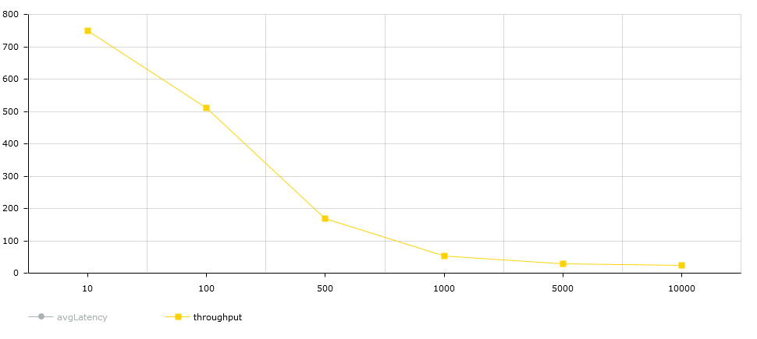
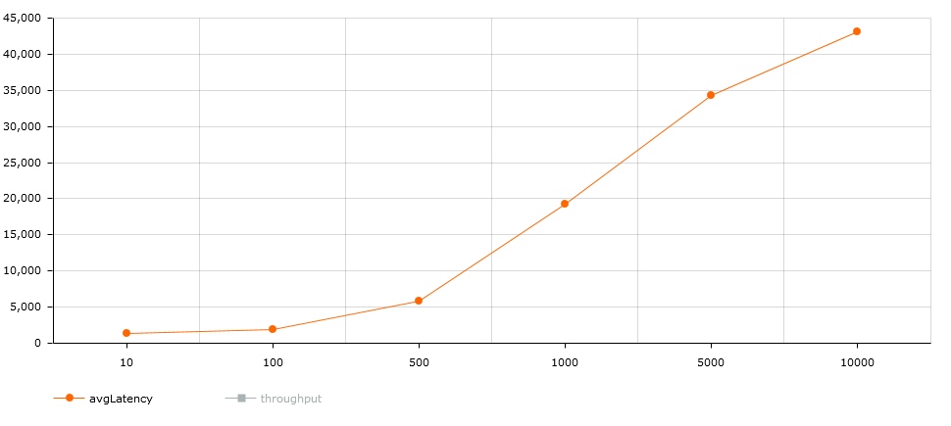

2.Average Latency and Throughput depending on the workload of all threads:

Latency increases and throughput decreases the bigger the workload for the threads is.
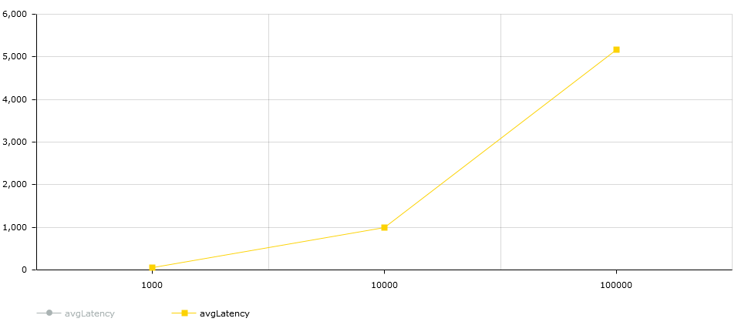
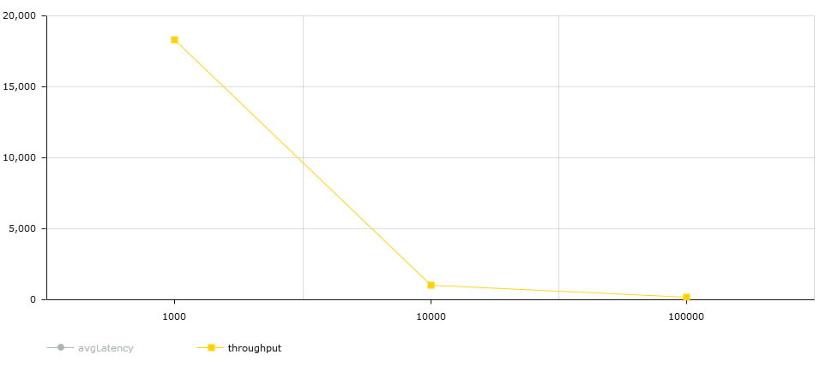

3.Average Latency and Throughput when the first thread has a fixed workload (100.000) and the other 2 threads change workload:

As with the previous test, latency rises and throughput decreases when workload is increased, but the rate at which this happens is lower than before.
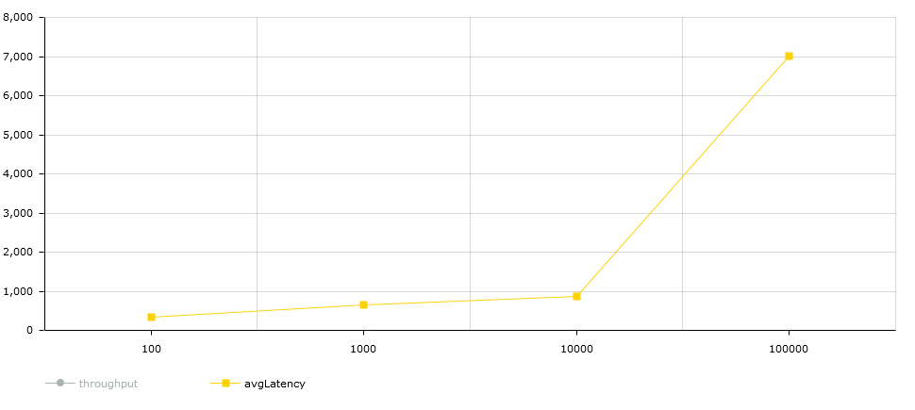
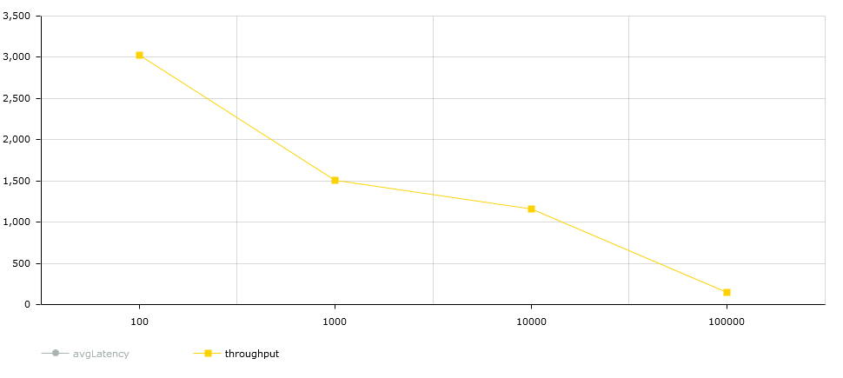

PART 3
1.Average Latency and Throughput based on N_DATA:

Throughput seems to be getting higher, while the average latency is going lower.

Throughput chart

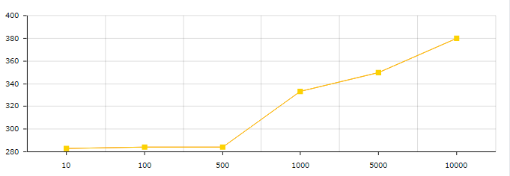

AvgLatency chart

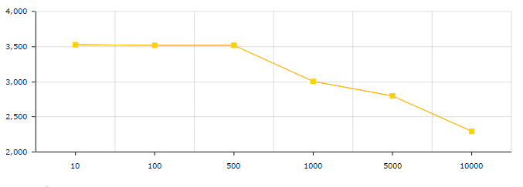

2.Average Latency and Throughput depending on the workload of all threads:

Throughput chart

